Attendee Portal

CloudCME allows you to register for CE activities, to manage your CE activities, and to obtain your CE certificates of completion.

Via Computer
Step 1: Go to: https://jefferson-lehigh.cloud-cme.com

Step 2: Click Sign In.

Step 3: Click the My CME or My CE button.

Step 4: Click the Profile button.

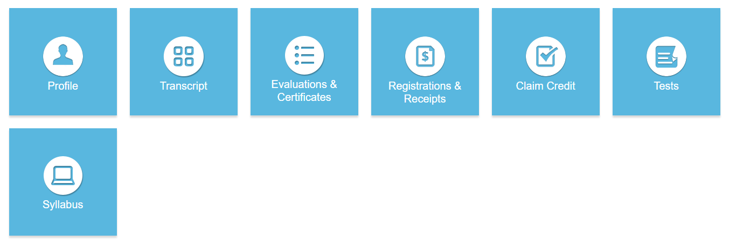
Step 5: Complete your profile. Required fields are marked with an asterisk.
NOTE: Make sure to select your Degree and Profession.

Step 6: When your profile is complete, click the Submit button at the bottom of the screen.

Registering for a CE Activity

At the top of the screen, you will see a menu panel. The options displayed across the top will differ among organizations.

Click the option you are interested in attending.

You can scroll through the course listing, read course details, and select activities that you are interested in attending. If registration is available, a Register button will display allowing you to complete the activity registration process.

When logged into CloudCMEâ, you will see several tiles available to you in the My CE/My CME section. Most tiles provide information on your registered CE activities.

A description of each tile is below:

Profile - allows you to complete information about your CloudCME® account. Select your profession and degree so that you receive the appropriate CE credit upon activity completion.

Transcript - allows you to manage your transcript records. The transcript contains continuing education activities completed in CloudCME® as well as external credit activities completed outside your organization.

Evaluations & Certifications - allows you to access and complete activity evaluations. Once the evaluation is completed (if required), certificates of completion are generated.

Registrations & Receipts - allows you to view activities for which you have registered. If fees were required for registration, you can access receipts, view pay status details and other information.

Claim Credit - allows you to self-claim credit for activities you have attended but did not receive credit for in the Attendee Portal.

External Credits – allows you to submit and view external credit records. External credits are continuing education credits you earned from completing continuing education activities provided outside of your institution. To submit your external credit record(s), click the Claim External Credits button and then complete the fields for submission.

Tests - allows you to access activity content such as videos or PDFs, access the activity tests, join virtual meetings, and allows you to view your test results.

Syllabus - allows you to view the syllabus for registered activities, view the syllabus information, and view presentations that were given during the activity, if published.

Transcripts
Step 1: To search for transcripts, select a date range for your transcript records or filter by credit type.
Step 2: Enter a Start Date and an End Date.

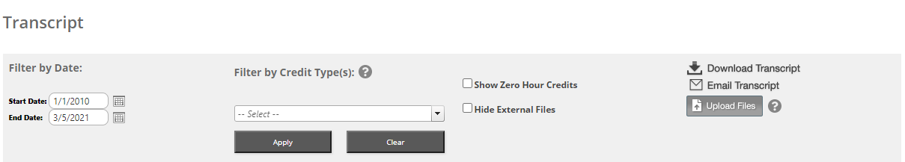
You may append transcripts from activities completed outside of your organization. These will display at the end of your CloudCMEâ transcript.
To append a transcript to your CloudCMEâ transcript, click the Upload Files button and select the file(s) to append.

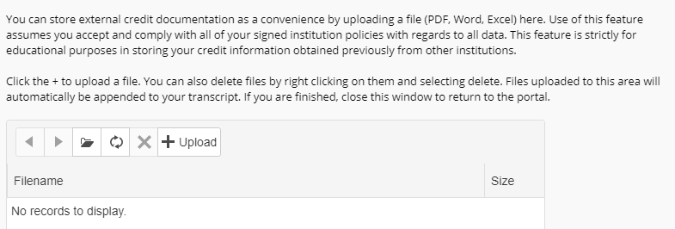

Transcripts may be emailed to a recipient or downloaded.
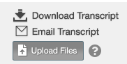

Evaluations & Certificates
Locate the activity you completed from the list. Complete the evaluation (if required), and your certificate of completion button will display.
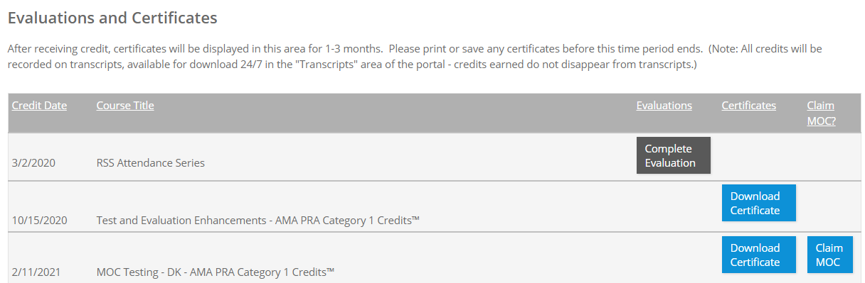

You can download a PDF version of the certificate or email the certificate.

Registrations & Receipts
You can view all the activities that you are registered for on this screen, along with activity details. If there are fees associated with the activity, click the Receipt button to view receipt details as well as your pay status.
Receipts may be printed or emailed.

Claim Credit

If your organization has enabled this feature, you can receive credit for activities you have attended but did not receive credit.

Step 1: Click on the Claim Credit button, if available.

Step 2: Enter the Activity ID.

Step 3: Click the Submit Activity ID button.

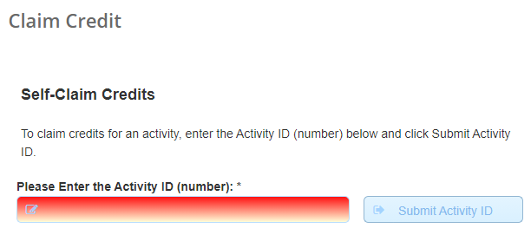

External Credits

To submit your external credit record(s):

Step 1: Select a date range

Step 2: Click the Claim External Credits button.

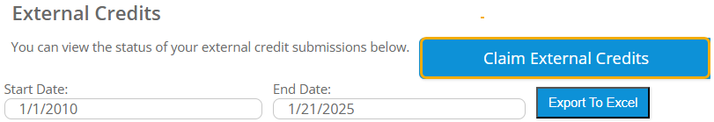

Step 3: Complete the fields for submission and click Submit.

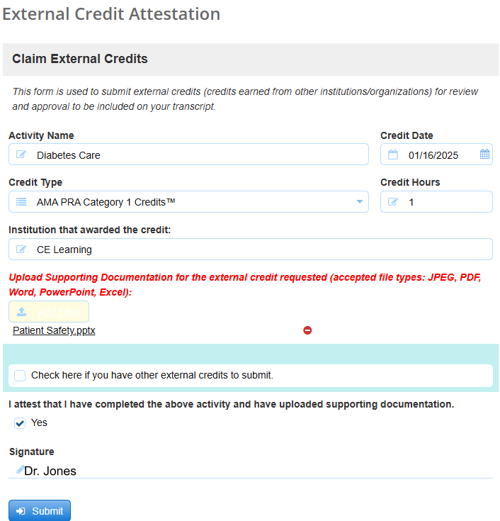

Tests

Step 1: Click the Tests button and locate the activity from the list.

Step 2: Click Post-Test or Pre-Test button (depending on testing requirements) and complete the activity test.

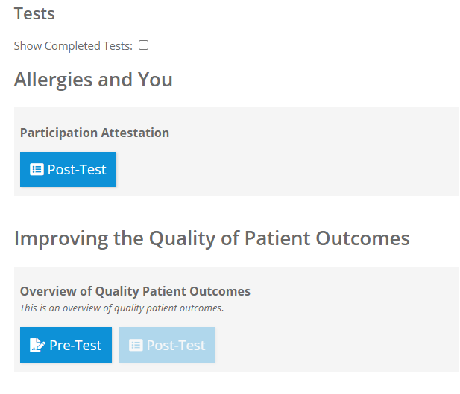

Step 3: Once you have completed the test, click the Show Results button.

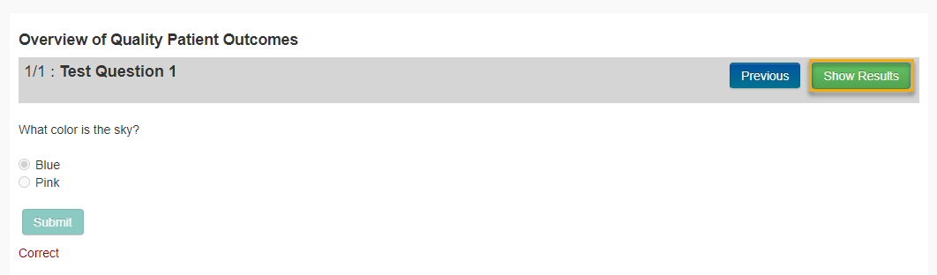

Your test results will display.

Step 4: If an evaluation is required after test completion, click the Complete Evaluation button.

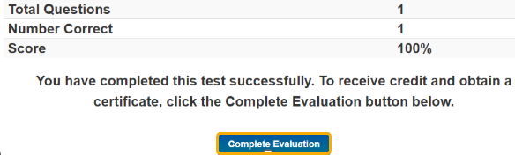

You can view your test results or access activity content by clicking the Test Results button.

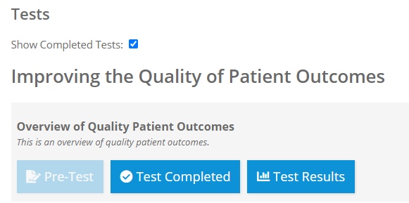

You can also view presentations, watch video content, and join virtual meetings.
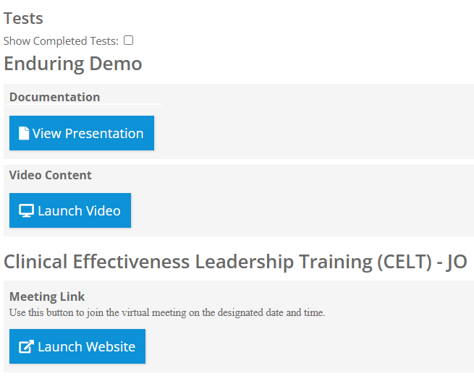

Syllabus

Step 1: Click the Syllabus button next to the activity.

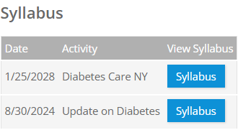

The activity syllabus will display.

Step 2: For presentations, click on the presentation icon to view the presentation.

Via CloudCMEâ Mobile App
Step 1: Download the CloudCME Mobile App if you have not already.
Step 2: Open the app, use organization code {Enter your organization’s code}.

Step 3: Click the Login with your Username and Password button.
Step 4: Login using your email address and password.

NOTE: The features that are available in the CloudCME Mobile App are set by your institution.

